AnaDoc – Cloud Document Analyzer

TEAM MEMBERS :
k. Sai Vibhas – 23BIT0438 D.
Lakshmi Aneela – 23BIT0415
B.K.Pranavi – 23BIT0314
P.Prudhvi Sai – 23BIT0429

TITLE : AnaDoc – Document Analyzer using AWS Cloud

DESCRIPTION :
The AnaDoc – Document Analyzer is a serverless cloud-based application designed to automatically extract and summarize the textual content of uploaded PDF files.
It leverages AWS services like Lambda, S3, and CloudWatch to perform file processing without any need for servers or manual setup.
When a user uploads a PDF document to a specific S3 folder, a Lambda function is triggered. The Lambda function reads the file, extracts its text using the PyPDF2 library, performs a basic text analysis, and generates a short summary that highlights the most common and meaningful words in the document.
This summary is then saved back into another folder in the same S3 bucket for easy access.
The project demonstrates how cloud computing can automate document analysis in a cost-efficient and scalable way, making it suitable for applications such as digital libraries, corporate archives, and automated reporting systems.

OUTCOME :
The AnaDoc – Document Analyzer project successfully demonstrates how AWS Free Tier services can be integrated to automate PDF text extraction and summarization without any server setup or manual intervention.
By using Amazon S3 for storage, AWS Lambda for execution, and CloudWatch for monitoring, the system automatically triggers whenever a PDF file is uploaded to the S3 bucket. The Lambda function reads the file, extracts the text using the PyPDF2 library, analyzes the content, and generates a short summary highlighting the key words or themes from the document. The resulting summary is then saved back into the S3 bucket for easy access.
The outcome proves that:
- The project can accurately extract and summarize text-based PDFs.
- The solution is completely serverless and runs efficiently on the AWS Free Tier.
- It provides real-time document processing, suitable for automation and educational use.
Thus, the AnaDoc Document Analyzer achieves its objective of creating a cost-effective, scalable, and fully automated document summarization system using cloud computing concepts.

PROBLEM STATEMENT :
Manual analysis of long or multiple documents is time-consuming and inefficient.
Organizations and individuals need an automated solution that can quickly summarize important details from uploaded PDFs. The challenge is to build such a system using only AWS Free Tier services without relying on paid AI APIs

KEY TECHNOLOGIES USED :
Technology | Purpose
Amazon S3 | Stores input PDFs and output summaries
AWS Lambda | Executes Python code automatically on new uploads.
AWS IAM | Provides role-based access between services.
Amazon CloudWatch | Logs and monitors Lambda execution.
Python 3.11 | Main programming language used.
PyPDF2 | Library used for text extraction from PDF files.

OVERVIEW :
The AnaDoc – Document Analyzer is a cloud-based serverless
application that extracts and summarizes text from uploaded PDF files. It uses Amazon S3 for file storage, AWS Lambda for automatic processing, IAM for secure access control, and CloudWatch for monitoring.
When a user uploads a PDF to the S3 bucket, the Lambda function automatically triggers, processes the PDF using Python, and saves a summary back to S3.
This project shows how AWS Free Tier services can automate document analysis efficiently and cost-effectively.

OBJECTIVES :
- To design and deploy a serverless PDF analyzer using AWS Lambda.
- To integrate Amazon S3 for secure file storage and retrieval.
- To implement automatic text extraction and summarization using Python (PyPDF2).
- To maintain logs and monitor performance using Amazon CloudWatch.
- To ensure free-tier compatibility without using paid AI services

SYSTEM ARCHITECTURE :

WorkFlow
- The user uploads a PDF document to the designated folder (input-files/) within the Amazon S3 bucket.
- The upload event automatically triggers the AWS Lambda function, which initiates the document processing pipeline.
- The Lambda function reads the uploaded PDF file directly from S3 and extracts its text content using the PyPDF2 Python library.
- The extracted text is then analyzed and summarized using a word-frequency–based summarization algorithm, which identifies the most significant keywords and themes from the document.
- The generated summary is stored back into the S3 bucket, specifically inside the summaries/ folder, in a .txt format.
- During each execution, Amazon CloudWatch records detailed logs about the Lambda function’s performance, including successful runs, errors, and processing duration, ensuring complete monitoring and transparency of the workflow.

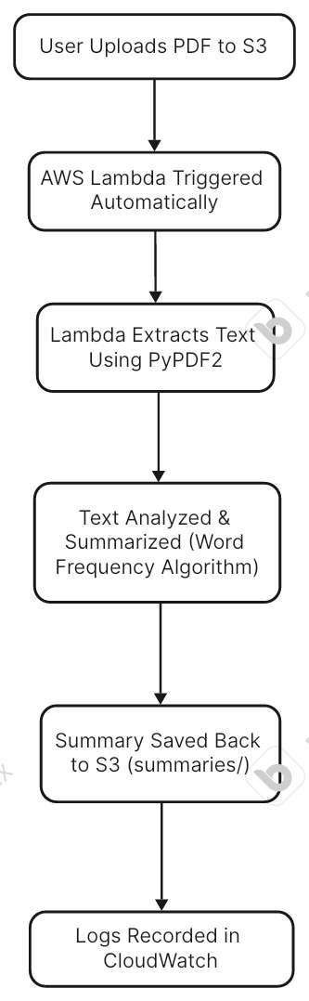

PROCEDURE :
Step 1 – Create an S3 Bucket
1. Go to the AWS Management Console → S3 Service.

Click “Create bucket.”
- Enter a name (example: anadoc-bucket) and select your region (e.g., ap-south-1).
- Keep all default options and click Create bucket.
- Inside your bucket, create two folders:
o input-files/ → for PDF uploads _{o} summaries/ → for output text summaries

S3 Bucket ( my-document-storage)
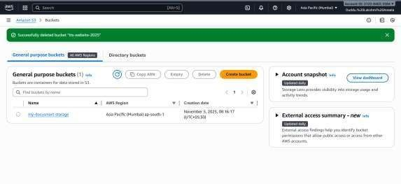

Folders inside Bucket : input-files/ → Stores uploading input files summaries/ → Stores the summaries of uploaded files
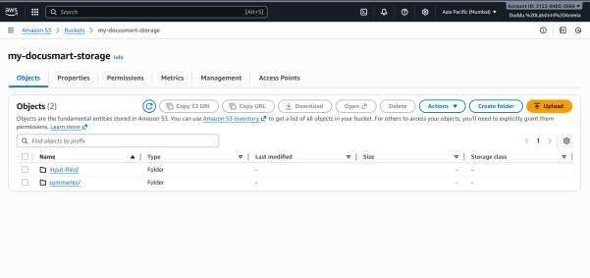

Step 2 – Create an IAM Role for Lambda
- Go to IAM → Roles → Create role.
- Choose AWS Service → Lambda and click Next.
- Attach the following policies: _{o} AmazonS3FullAccess _{o} CloudWatchFullAccess
- Name it LambdaS3AccessRole and click Create role.

Created IAM User
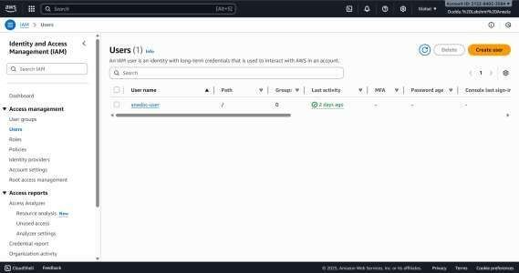
User Summary And Policies Used :
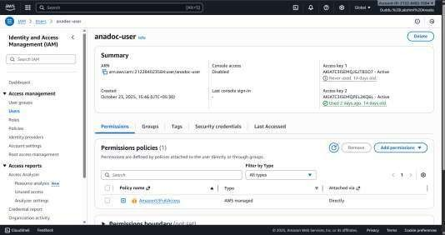

Step 3 – Create a Lambda Function
- Go to AWS Lambda → Create Function.
- Select: o Author from scratch _{o} Function name: AnaDocLambda _{o} Runtime: Python 3.11 _{o}
Execution role: choose Use an existing role → LambdaS3AccessRole
- Click Create function.

Created Lambda Function (DocuAnalyzer)
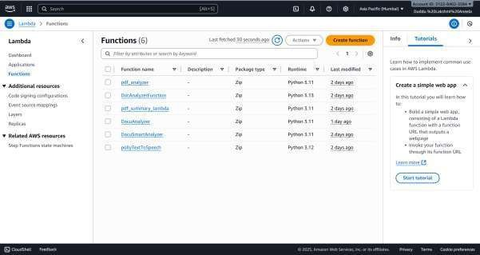

Function OverView
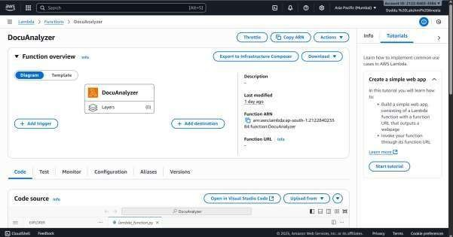

Step 4 – Add Dependencies (PyPDF2 and boto3)
- In your local system, create a new folder named AnaDocLambda.
- Open Command Prompt inside it:
- cd C:\Users\Lenovo\Downloads\AnaDocLambda 4. pip install PyPDF2 -t .
- pip install boto3 -t .
- Copy your lambda_function.py file into this same folder.
- Select all files → Right-click → Send to → Compressed (zipped) folder → name it anadoc_lambda.zip.

Folder Structure
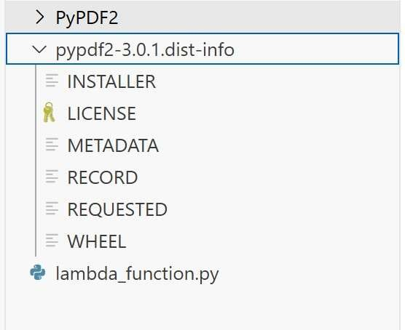

Step 5 – Upload Code to Lambda
- In the Lambda console → open your function → Code tab.
- Click Upload from → .zip file and select anadoc_lambda.zip.
- Click Deploy.
- Under Configuration → General Configuration, edit timeout to 1 minute.

Code Source Taken
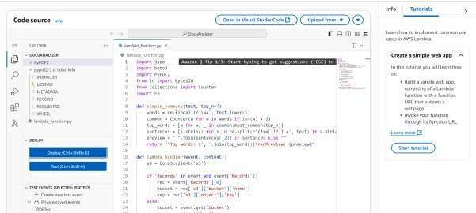

Code
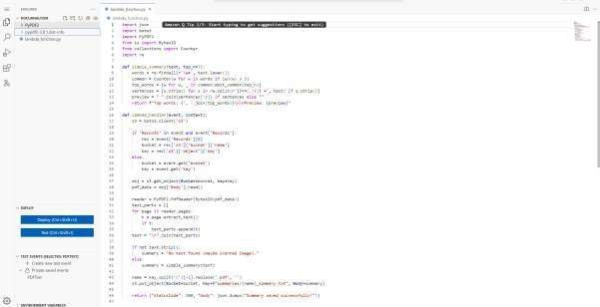

Step 6 – Test Lambda
- Click Test → Configure test event.
- Use the following sample JSON:
{
"bucket": "anadoc-bucket",
"key": "input-files/sample.pdf"
- }
- Click Save and Test.
- Check the output — it should display:
{
"statusCode": 200,
"body": "Summary created successfully!" }

Test Event (PDF Test) Along with Event JSON
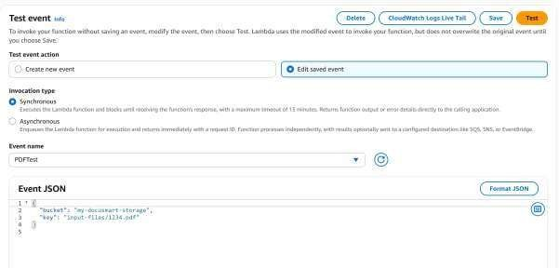

After SAVE and TEST (Execution Details )
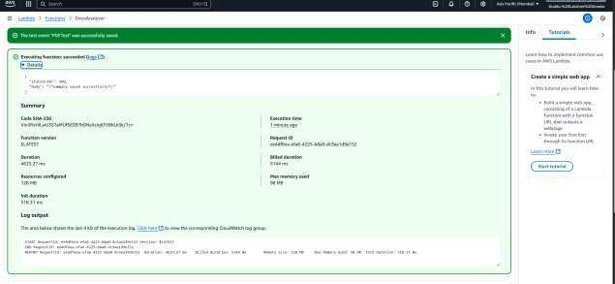

Step 7 – Verify Output in S3
- Go to your S3 bucket → open the summaries/ folder.
- You’ll find a file like sample.txt.
- Open it to view your summary:

INPUT Files Given
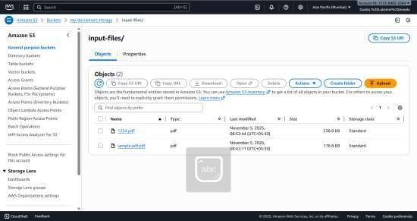

Sample.pdf Properties And the matter inside it
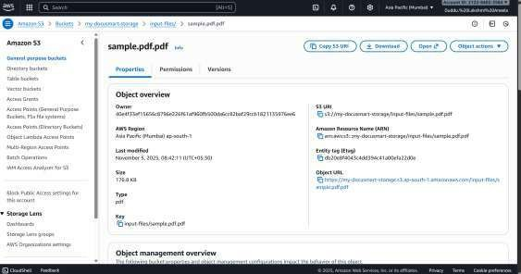
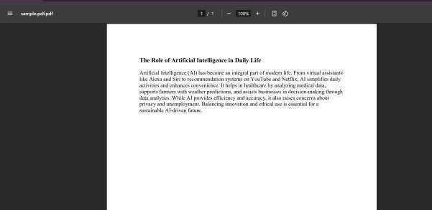

Summaries Got
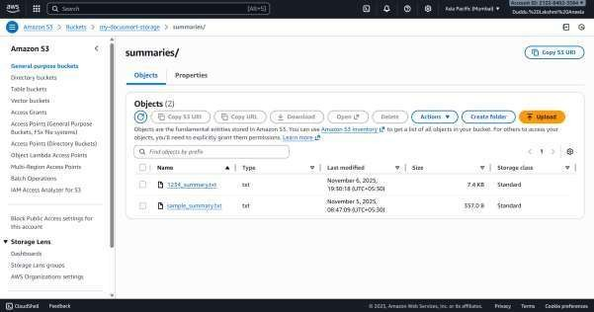

Sample_Summary.txt Properties and OUTPUT SUMMARY
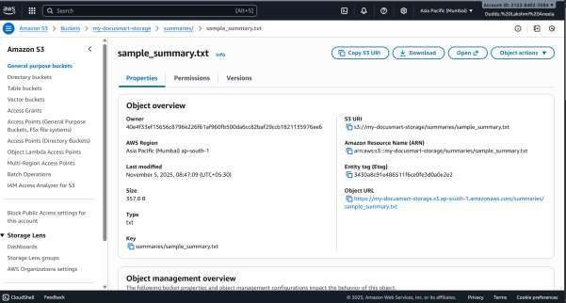

After Clicking the Open button it will automatically download the required output Summary file into your pc in Text format THE SUMMARY FILE OF sample.pdf
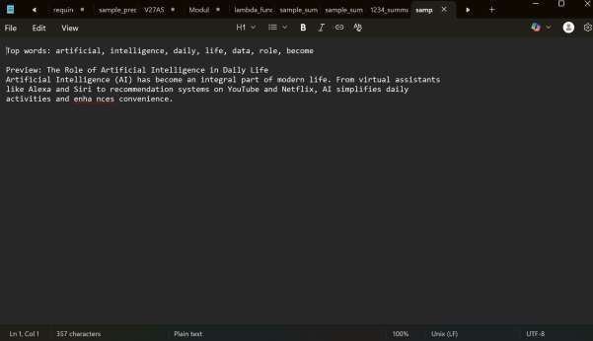

Step 8 – Monitor in CloudWatch
- Go to CloudWatch → Logs → Log groups →
/aws/lambda/AnaDocLambda.
- View execution details and error logs if needed.

CloudWatch LogGroup ( /aws/lambda/DocuAnalyzer)
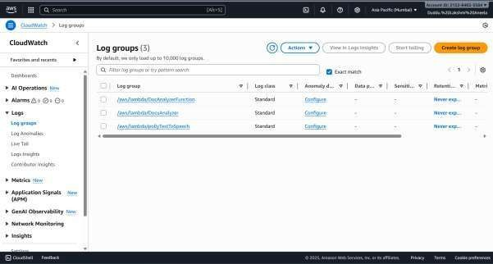

Log Streams
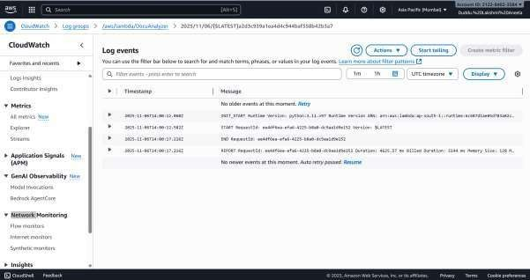
RESULT :
The AnaDoc – Document Analyzer successfully analyzes uploaded PDF files, extracts text, and provides short summaries automatically through AWS Lambda.
The output summary file is generated within seconds and stored back in S3, ensuring a fully automated workflow.

ADVANTAGES :
- Fully serverless and cost-free.
- Automatically processes files without manual intervention.
- Easy to monitor through CloudWatch logs.
- Scalable and compatible with AWS Free Tier.

LIMITATIONS :
- Cannot process scanned image-based PDFs (only text-based).
- Summarization is keyword-based, not semantic.
- Large PDFs may slightly increase processing time.

FUTURE ENHANCEMENTS :
- Add Amazon Textract for OCR and scanned PDF analysis.
- Integrate Amazon Bedrock or OpenAI API for advanced summarization.
- Build a web interface for easy upload and result viewing.
- Use DynamoDB to store summaries for search and indexing.

CONCLUSION :
The AnaDoc – Document Analyzer project successfully demonstrates how cloud computing and serverless architecture can be utilized to automate document processing in an efficient, scalable, and costeffective way. By integrating Amazon S3, AWS Lambda, IAM, and CloudWatch, the system eliminates the need for manual intervention, dedicated servers, or expensive AI tools. It performs seamless text extraction and summarization from uploaded PDF files and stores the results automatically in the cloud.
This implementation highlights the flexibility and simplicity of AWS Free Tier services, proving that even complex automation tasks can be achieved with minimal infrastructure setup. The use of Lambda ensures automatic execution and easy scaling, while S3 provides reliable storage and CloudWatch ensures effective monitoring and debugging.Overall, AnaDoc provides a practical example of cloudbased automation, showcasing how students and developers can build intelligent systems on the AWS platform without cost overheads. In the future, this system can be expanded with AI summarization, OCR capabilities, and user interfaces, making it a strong foundation for advanced document management solutions in both academic and industrial applications

